Charltons - Hong Kong Law - 18 October 2022
online version
HKMA Issues Position Paper on e-HKD
On 20 September 2022, the Hong Kong Monetary Authority (HKMA) released a position paper entitled “e-HKD: Charting the Next Steps” outlining its next steps on the direction of the e-HKD and its policy stance on a retail Central Bank Digital Currency. The HKMA is planning to begin testing various components of the e-HKD this quarter while simultaneously laying the digital infrastructure and legal foundations to support the e-HKD. The plan aims to future-proof Hong Kong with regards to being CBDC ready. The position paper is available here on the HKMA’s website.
Hong Kong’s Development of the e-HKD
The HKMA began researching Central Bank Digital Currencies (CBDCs) under Project LionRock in 2017. In 2019, the Bank of Thailand began collaborating with the HKMA to study the application of wholesale CBDC (wCBDC) to cross-border payments, and they were joined in 2021 by the Digital Currency Institute of the People’s Bank of China, the Central Bank of the United Arab Emirates, and the Bank for International Settlements Innovation Hub (BISIH) Hong Kong Centre. The HKMA began research into retail CBDCs (rCBDC) in 2021 and joined with BISIH Hong Kong Centre to study the high-level technical design of rCBDC under Project Aurum.
With the COVID pandemic accelerating the pace of market digitalisation, the HKMA considered it necessary to thoroughly research whether and how rCBDC can play a role in supporting and rationalising the relevant market developments. Project e-HKD was launched in June 2021, with a near term objective of formulating an initial view on the direction to pursue after identifying and considering the key issues involved.
Project e-HKD, similar to other wCBDC projects undertaken by the HKMA, has examined the potential for applying the latest technology to address existing and evolving payment demands. Drawing on the experience of other jurisdictions and knowledge gained from Project Aurum, the HKMA has identified potential high level architectures and design options for e-HKD leveraging Distributed Ledger Technology (DLT).
If issued, the e-HKD is expected to play a significant role in the Hong Kong economy and to have a broad interface with the Hong Kong public. Its adoption would have far-reaching implications in a number of areas including legal, policy, financial stability and interaction with existing payment methods. Many advanced economy central banks share this view and have indicated that it could take years of careful study before they adopt their version of CBDC.
Hong Kong’s e-HKD Market Consultations
On the technical front, the HKMA published a technical whitepaper in October 2021 entitled “e-HKD: A technical perspective”, which explored potential architectures and design options for issuing and distributing e-HKD. On the policy front, the HKMA published a policy discussion paper in April 2022 entitled “e-HKD: A policy and design perspective”, which examined the key policy and design issues in introducing the e-HKD, including the potential benefits and challenges, the issuance mechanism, interoperability with other payment systems, privacy and data protection and legal considerations, as well as potential use cases.
The feedback received for the technical whitepaper was generally positive and supportive of the e-HKD. Respondents believed that it has the potential to make payments more efficient and would support the digital economy. Respondents’ views on the rCBDC varied on use cases and design choice, although there were areas of significant agreement including on: the design taking a holistic approach, seeking to protect user privacy while supporting legal and regulatory compliance, achieving the highest level of cybersecurity to maintain public trust and supporting a wide range of payment means and different transaction systems. It was also agreed that the rCBDC ecosystem should be open and inclusive to support a diverse set of participants and rCBDC wallet providers.
For the policy discussion paper, respondents generally agreed with the potential benefits and challenges discussed. There was also general agreement on the adoption of a two-tier distribution model, preference for e-HKD to be unremunerated, and suggestions for the e-HKD to support offline payment and cross-border payment (perhaps with the possibility of flexible conversion between the e-HKD and the e-CNY).
HKMA’s Next Steps for the e-HKD
Given the comments received from the two market consultations and the findings of its own study, the HKMA believes it is necessary to begin paving the way for the possible future implementation and use of the e-HKD. At the time of publication of the position paper, roughly 20% of central banks worldwide were developing or testing an rCBDC, with only The Bahamas (Sand Dollar) and Nigeria (eNaira) having launched a live rCBDC, and Mainland China (e-CNY) and the Eastern Caribbean (DCash) having released a pilot version of their rCBDC.
While it appears that the e-HKD might not have an immediate role to play in the current retail payment market, the HKMA believes that uses for the e-HKD can emerge quickly out of the rapid evolution, or perhaps even revolution, of the digital economy. It is possible that a CBDC will have the potential to answer calls from the international financial community for a more efficient cross-border payment and remittance solution and enhanced connectivity and interoperability between jurisdictional payment systems. A CBDC also has the potential to provide stability in the crypto and decentralised finance markets.
The HKMA therefore plans to start laying the foundations for the implementation and application of an rCBDC. In-depth studies will be conducted with efforts being paid to maintain a good level of flexibility so that the foundations can be made as forward-compatible as possible to accommodate scenarios that might occur in the future. In short, the HKMA will adopt a three-rail approach in preparing for the possible implementation of the e-HKD in the future, as depicted by the following diagram.
HKMA’s three-rail approach to preparing for possible e-HKD implementation
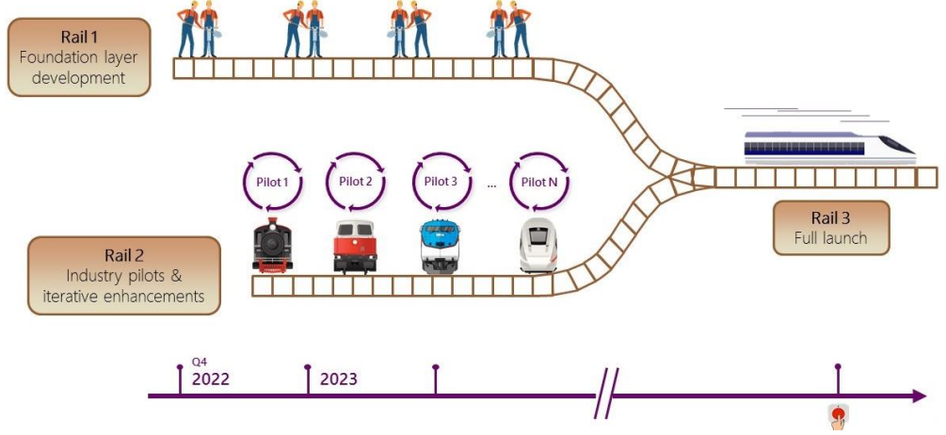
Source: HKMA Position Paper – e-HKD Charting the Next Steps
Rail 1: Laying the Foundations for e-HKD
Rail 1 aims to lay the legal and technological foundations for supporting the future implementation of the e-HKD.
On the legal front, the main area of attention will be enabling the issuance of a digital form of fiat currency with legal tender status. The current legal framework is insufficient to accommodate the issuance of a digital form of legal tender. An unambiguous legal foundation is crucial to fostering public confidence in the currency, and ensuring alignment between the digital and physical forms of the Hong Kong dollar.
On the technology front, the retail layer is expected to be impacted by a broad range of factors, some of which are yet to be fully articulated and deliberated. Therefore, the wholesale interbank tier (wholesale layer) will be developed first. A system development plan, including the project timeline, system design, and resources planning will be formulated in around June 2023. It is expected that a wholesale layer of production grade will take at least two to three years to build.
Regarding enacting legislation, the HKMA will cooperate with the Government in identifying areas needing new legislation or amendments. The timeframe for this process will depend on the complexity of the legislative proposals, whether legislative amendment ‘slots’ are available, and the time required for a bill to be considered by the Legislative Council.
Rail 2: Deep-Dive Research and e-HKD Pilot Programmes
Rail 2 will run parallel to Rail 1, taking deep dives into use cases and implementation and design issues relating to the e-HKD, including conducting research into application issues and running a series of pilots with various stakeholders, including banks and the industry. The HKMA will build on the experience and insights gained from the pilots to enrich and refine its approach to the implementation of the e-HKD. This approach should help with better decision making on design choices for the retail layer of the e-HKD system and the tools and devices developed may also be utilised for the later, actual implementation of the e-HKD.
Projects and tasks currently in the pipeline include:
- Access to e-HKD via the e-wallet app
- Project Sela on cybersecurity
- Technical deep dives on privacy and performance
- DvP settlement of tokenised securities
- Industry engagements on rCBDC use cases and design choices
- Regulations prescribing the framework for the issuance and use of e-HKD
- Studying the pros and cons of using CBDC as the on- and off-ramp instrument for DeFi
Rail 3: Rolling out the e-HKD
Rails 1 and 2 will lay the foundations for the future implementation of the e-HKD rollout. With Rail 3, the focus will be on the launch of the e-HKD. The HKMA admits that there will not be an immediate timeline projected for Rail 3 and the rolling-out of the e-HKD as there are still too many factors to consider to accurately plan a timeline. The progress of Rail 1 and Rail 2 and the relevant market development, both local and international, will affect the timeline. However, the HKMA believes the work completed on the first two rails should put Hong Kong in an advantageous position in terms of responsiveness to emerging market demands and enable it to launch Rail 3 reasonably expeditiously. In terms of any future e-HKD rollout, the HKMA will pay close attention to emerging market trends and international developments.
This newsletter is for information purposes only.
Its contents do not constitute legal advice and it should not be regarded as a substitute for detailed advice in individual cases.
Transmission of this information is not intended to create and receipt does not constitute a lawyer-client relationship between Charltons and the user or browser.
Charltons is not responsible for any third party content which can be accessed through the website.
If you do not wish to receive this newsletter please let us know by emailing us at unsubscribe@charltonslaw.com
Charltons - Hong Kong Law - 18 October 2022

A CBDC is a central bank-issued digital money which is issued by a central bank rather than a commercial bank or a private financial institution.
Project LionRock was conducted by the HKMA in collaboration with the three note-issuing banks (The Hongkong and Shanghai Banking Corporation Limited, Bank of China (Hong Kong) Limited, and Standard Chartered Bank (Hong Kong) Limited) and Hong Kong Interbank Clearing Limited.
Wholesale CBDC are intended for the settlement of large interbank payments or to provide central bank money to settle transactions of digital tokenised financial assets in new infrastructures.
Retail CBDC, also referred to as “general purpose” CBDC, are intended for use by the general public. For Hong Kong, this can be the digital version of its fiat currency and can be circulated as currency and be accorded legal tender status.
The technical whitepaper is available on the HKMA website at https://www.hkma.gov.hk/media/eng/ doc/key-functions/financial- infrastructure/eHKD_A_technical_perspective.pdf
The discussion paper is available on the HKMA website at https://www.hkma.gov.hk/media/eng/doc/ key-functions/financial-infrastructure/eHKD_A_Policy_and_Design_Perspective.pdf
Kosse, A and I Mattei (2022): “Gaining momentum – Results of the 2021 BIS survey on central bank digital currencies”, BIS Papers, no 125, May. https://www.bis.org/publ/bppdf/bispap125.pdf. The launch of the 4 rCBDC were mainly driven by financial inclusion, competition, and operational resilience of payment systems, which are less relevant in Hong Kong.
Project Sela is a joint HKMA, Bank of Israel, and BISIH Hong Kong Centre project, studying cybersecurity issues in the context of rCBDC. In particular, it will study data security implications of a two-tier rCBDC architecture where the intermediaries will have no financial exposure, and pioneer methods to make the architecture more resilient to cyberattacks.

